Pizza Sales Analysis (SQL Queries)

1. KPI’s

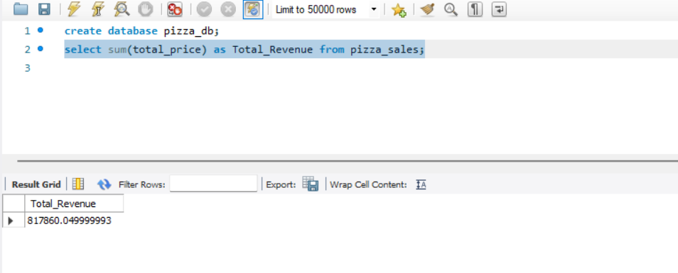1.Total Revenue

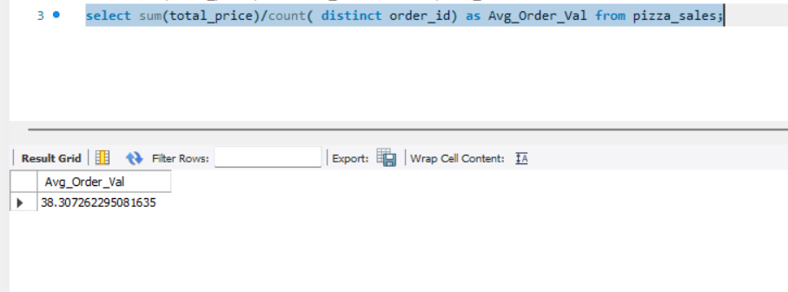2. Average Order Per Value

3. Total Pizza Sold

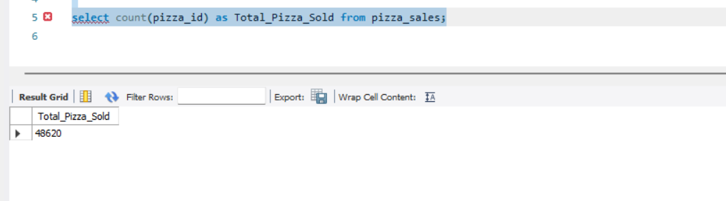

4. Total Order

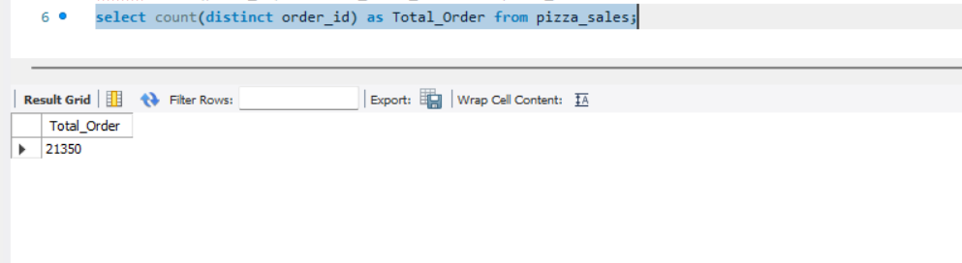

5. Average Pizza Per Order

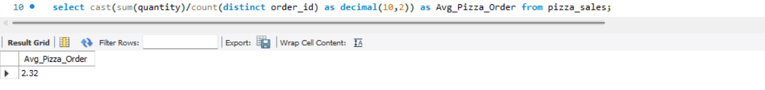

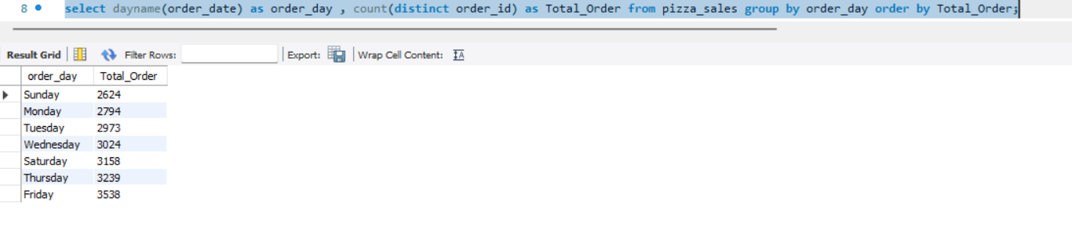B.Daily Trend For Total Order

1. 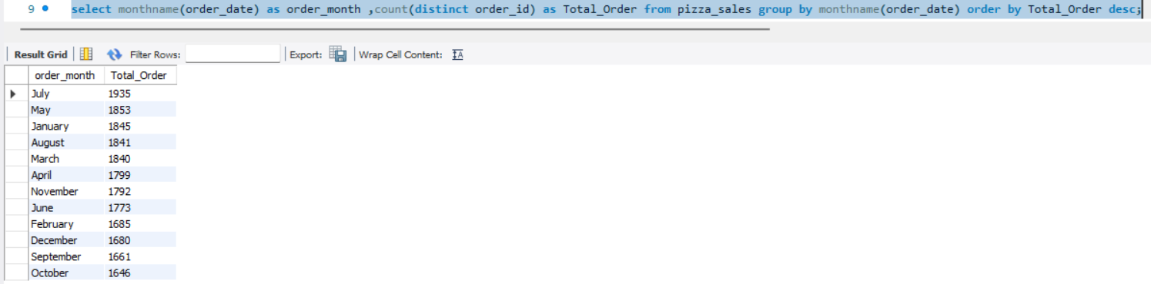Monthly Trend For Total Orders
2. 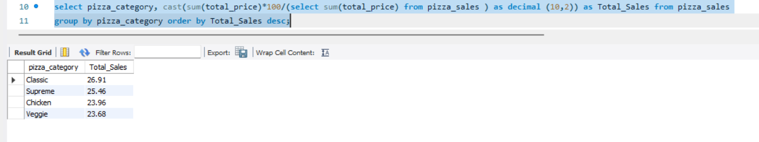% Of Sales By Pizza Category
3. 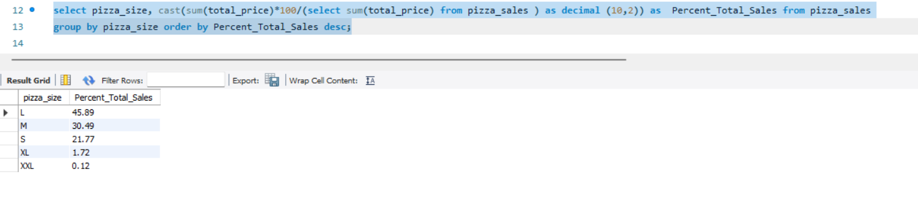% of Sales By Pizza Size
4. 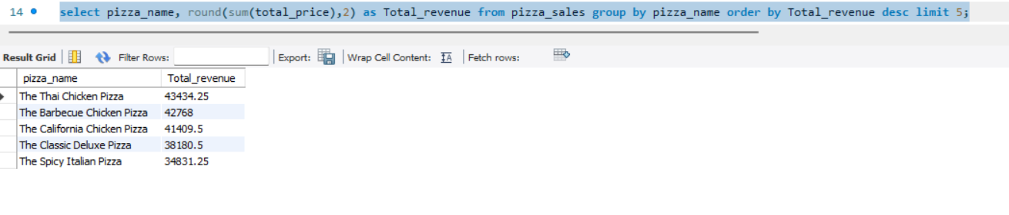Top 5 Pizza Sellers By Total Revenue
5. 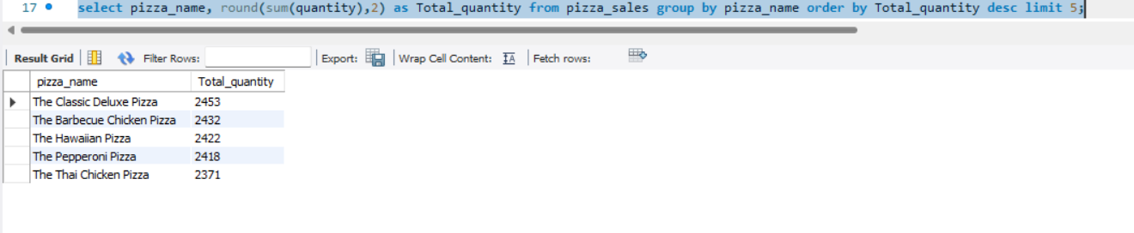Top 5 Pizza Sellers By Total Quantity
6. 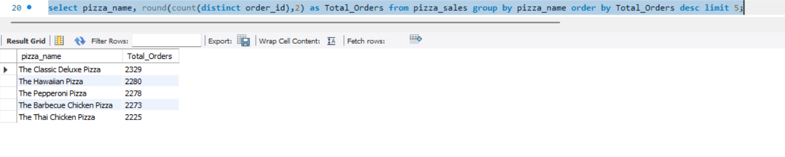Top 5 Pizza Sellers By Total Orders
7. 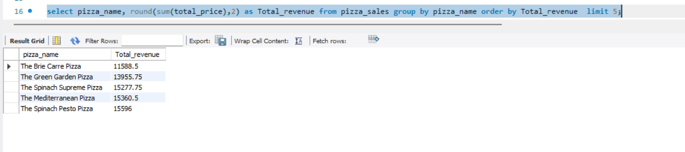Bottom 5 Pizza Sellers By Total Revenue
8. 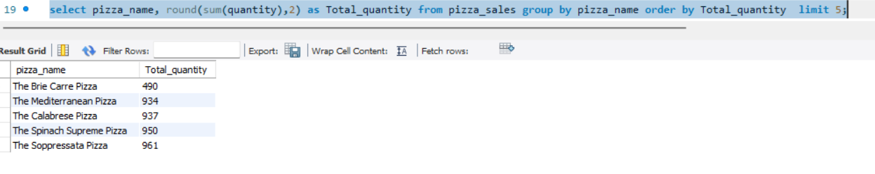 Bottom 5 Pizza Sellers By Total Quantity

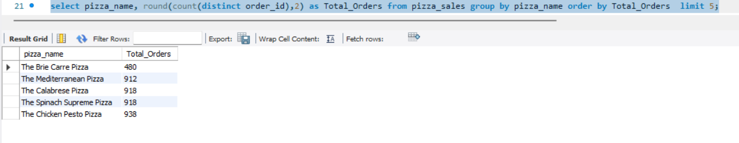K. Bottom 5 Pizza Sellers By Total Orders